Form LRA-47 (r. 60(2)(b)(ii), 63(2)(c))

REPUBLIC OF KENYA

THE LAND REGISTRATION ACT

THE LAND REGISTRATION (GENERAL) REGULATIONS, 2017

GENERAL FORM OF STATUTORY DECLARATION

I, ………SOLOMON NYONGESA ………………………(in support of this Application) do hereby sincerely declare
as follows:-
…………………………………………………………………………………………………………Subject to the application made by the transferor, FRANCIS WAITHAKA in the presence of PTROUS DAVID of ID No 33251659 that the suit land LR No Kericho/ Chemoiben/ 693 situate within Litein has been transferred to GERTRUDE MULINGE of ID No 32187654 as the transferee in the presence of CHAO NATASHA of ID No 32187654.
…………………………………………………………………………………………………………This was certified in the presence of Mark Nabiswa who is the land registrar.

…………………………………………………………………………………………………

I make this declaration conscientiously believing the same to be true and according to the Oaths and Statutory Declaration Act.
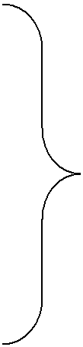

DECLARED before me at
……………Forenoon………………………
on the ………28th…………………… day
Of……………May………………………2024

……………………………………………..
Signature of Commissioner for Oaths
or Magistrate or Notary Public

